Lab experiment #1

**MEASUREMENTS AND EXPERIMENT ERRORS: DETERMINATION OF LENGTH, MASS, AND DENSITY**

**Pre-lab questions**

1. What is the goal of this experiment? What physics and general science concepts does this activity demonstrate to the student?
2. Is there a difference between accuracy and precision?
3. What can multiple measurements of a quantity improve?

The goal of the experiment is to get acquainted with using some laboratory instruments for measuring length and mass, with estimation of the instrumental uncertainties and errors typical of the results of measurements.

**Equipment** : meter stick, vernier caliper, micrometer caliper, metal cylinder, small sphere, laboratory balance.

**Introduction:**

**Basic Concept:** No physical quantity can be measured with perfect certainty; there are always uncertainties and errors in any measurement. This means that if we measure some quantity and, then, repeat the measurement, we will almost certainly measure a different value the second time. How, then, can we know the “true” value of a physical quantity? The short answer is that we can’t. However, as we take greater care in our measurements and apply ever more refined experimental methods, we can reduce the errors and, thereby, gain greater confidence that our measurements approximate ever more closely the true value.

“Error analysis” is the study of uncertainties in physical measurements, and a complete description of error analysis would require much more time and space than we have in this course. However, by taking the time to learn some basic principles of error analysis, we can:

1. Understand how to measure experimental error,
2. Understand the types and sources of experimental errors,
3. Clearly and correctly report measurements and the uncertainties in those measurements, and
4. Design experimental methods and techniques and improve our measurement skills to reduce experimental errors.

**Basic Practice:** When using a measuring device, it is necessary to estimate the fractional parts of the smallest scale division. For example, when using a meter stick to find the length of an object, we estimate the fraction of a millimeter from the last marked division imprinted to the end of our object. Some measuring instruments incorporate an attachment called a vernier scale to aid in finding this fractional unit.

The **vernier caliper** illustrated below in Figure 1 is a device which assists in estimating lengths to within a tenth of a millimeter. (Other vernier calipers may measure length to greater or lesser accuracy.) It has two scales: the fixed main scale and a movable vernier scale that slides along the fixed scale.

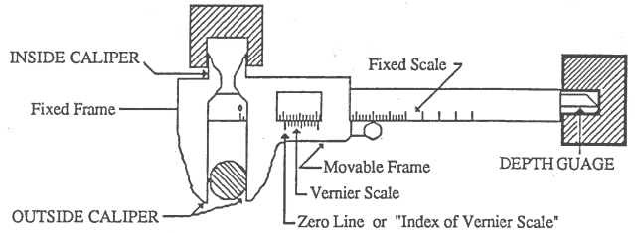

Figure 1. A vernier caliper

The smallest division of the main scale represents millimeters. The movable scale contains ten divisions each of which is nine-tenths as long as the smallest main-scale division. The distance between the jaws of the caliper is always the same as the distance between the zero marks on the two scales, which do not uniformly align. The main scale is read by looking at the location of the zero mark on the vernier scale. For example, the main scale reading on the caliper in Figure 2 is between 6 and 7 mm. The Vernier scale is read by looking to see which mark on the Vernier scale aligns with a mark on the main scale. In Figure 2, the 2nd vernier mark aligns with the “7” mark on the main scale, indicating another 0.2 mm of length. Thus, the length reading is 6.2 mm.

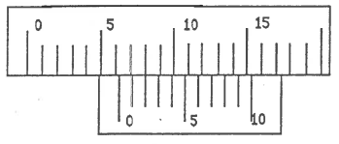

Figure 2

Try reading the length indicated in Figure 3 below. The vernier’s zero mark is between 3 and 4 on the main scale. Did you find 3.7 mm?

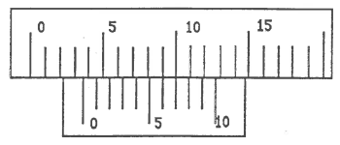

Figure 3

**The micrometer caliper**, shown in Figure 4, is an instrument designed for measurement of small distances to an accuracy of a **hundredth of a millimeter.** As shown, the jaw B is the end of the screw passing through the cylindrical nut carrying the scale S.

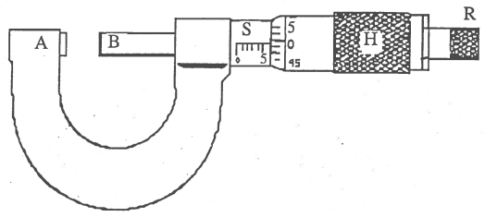

Figure 4. A micrometer caliper

The object to be measured is placed between the jaws A and B and the head H which carries the screw is advanced toward the zero end of the scale until contact is made with the object by both jaws. Correct pressure of the jaws is best determined by turning the ratchet R until it begins to slip. The distance the screw advances when turned through one revolution is called the pitch of the screw and it is equal to ½ mm for the laboratory micrometers. Hence, if the division on the scale S is a millimeter, the head will make two revolutions while advancing a distance of 1 mm between two marks.

Examination of the scale on the head shows that it contains 50 divisions, thus making the value of the smallest division equal to one fiftieth part of ½ mm, or 0.01 mm. Careful examination of the reading and the position of the head H with respect to the space between two marks on the scale S will always make it possible to determine whether the head has made more than one revolution since passing the last mark visible on the scale S. If, when the jaws are closed against each other, the reading on the scale is not zero, a zero-correction must be added to or subtracted from each reading scale. This is an example of a *systematic error* which will occur in each measurement unless a correction is made.

**Basics of Experimental Errors:** Experimental error is the difference between a measurement and the true value (accuracy) or between two measured values (precision).

* *Accuracy* measures how close a measured value is to the true value or accepted value. Since a true or accepted value for a physical quantity is often unknown, it is frequently not possible to determine the accuracy of a measurement. Systematic, or ‘one-sided’, errors are errors that affect the accuracy of a measurement. They are often caused by defective instruments or improper use of an instrument.
* *Precision* measures how closely two or more measurements agree with other. Precision is sometimes referred to as “repeatability” or “reproducibility.” A measurement which is highly reproducible tends to give values which are very close to each other. Random errors affect the precision of a measurement. They are ‘two-sided’ errors, frequently caused by fluctuations in instrument readings or difficulty in estimating an instrument’s reading. As ‘two-sided’, randomly fluctuating changes in the measurement value, they readily yield to improvement of precision with an increased number of independent measurements and statistical analysis.

**Percent error**, or fractional difference, measures the accuracy of a measurement by the difference between a measured or experimental value, *E*, and a true or accepted value, *A*. $\% Error=\frac{|E-A|}{A}$.

**Percent difference** measures precision of two measurements by the difference between the measured or experimental values, *E*1 and *E*2, expressed as a fraction the average of the two values. $\% Difference=\frac{\left|E_{1}-E_{2}\right|}{\left(\frac{E_{1}+E_{2}}{2}\right)}$.

Statistical measures of repeated measurements look at the grouping, or distribution, of values about a central, or mean, value. For a set of *N* measured values for some quantity, *x*, the **mean value** of *x* is represented by $〈x〉=\frac{1}{N}\left(x_{1}+x_{2}+…+x_{N-1}+x_{N}\right)=\frac{1}{N}\sum_{i=1}^{N}{x_{i}}$, where *x*i is the *i*’th measured value of *x*. With this, the **standard deviation** *σx* of measured values about the mean is defined by $σ_{x}=\sqrt{\left(\frac{1}{N-1}\right)\sum_{j=1}^{N}{{\left(x_{j}-〈x〉\right)}^{2}}}$. The standard deviation *σx* measures how widely spread the measured values are on either side of the mean value, $〈x〉$. For measurements which have only random errors, the standard deviation means that 68% of the measured values are within *σx* from the mean, 95% are within 2*σx* from the mean, and 99% are within 3*σx* from the mean.

Often, we have to combine several different measurements into one composite result. For example, measures of length, width, and height are needed to calculate a volume. Or measures of distance and time may be needed to calculate a speed. When multiple measures are combined, the uncertainty in each will contribute to the uncertainty of the whole. The method for combining multiple sources of error into a composite uncertainty is called **propagation of errors**.

The combined measure we end up with is called the **relative uncertainty**. The relative uncertainty (of any individual measure as well as the overall combination) is the ratio of the measure’s standard deviation to its mean value, like *σx*/. To begin, find the mean value and standard deviation for each measurement type. (Eg., the mean values and standard deviations of length, width, and height measurements for a volume measure.) Then the combined relative uncertainty is the square root of the sum-squared values of the component relative uncertainties. That is, for some combined measure *V* dependent on component measures *x*, *y*, and *z*, the combined relative uncertainty $\frac{σ_{V}}{〈V〉}=\sqrt{{\left(\frac{σ_{x}}{〈x〉}\right)}^{2}+{\left(\frac{σ_{y}}{〈y〉}\right)}^{2}+{\left(\frac{σ_{z}}{〈z〉}\right)}^{2}}$  
 .

**Experiment**

**Step 1.** PRELIMINARY MEASUREMENTS

1. **Vernier caliper**.

Using the vernier caliper, make five separate measurements of the diameter of a coin and record on the data in the Table 1 provided below. (Practice on other objects until you are sure you know how to read the instrument. Unlike the example vernier caliper described above, the instrument you will use may have an accuracy of 0.05 mm instead of 0.1 mm. Check the vernier scale of your device to determine this.)

1. **Micrometer caliper**.

Watch how the scale reading changes as you carefully close the jaws. *Be sure you do not force the screw*. Determine the zero correction and record it as + or -, depending whether it is to be added to, or subtracted from actual instrument readings and record it.   
  
Using the micrometer caliper, make and record five separate measurements of the diameter of the same coin.

1. **Compare results.**  
     
   Calculate the mean diameter value from the vernier caliper and micrometer caliper measurements, separately. Calculate the standard deviation for each case. Also, calculate the mean coin diameter from both sets of measurements. *Use the correct number of significant figures in all your values.*  
     
   Compare the results of measurements with the micrometer caliper and with the vernier caliper. Which is more accurate?

## Table 1. Preliminary Measurements

|  |  |  |  |
| --- | --- | --- | --- |
| Coin Denomination | Vernier Caliper | Micrometer Caliper | |
|  |  | Zero correction = | |
| Trial | Diameter (mm) | Diameter (mm) | Dia. Corr. (mm) |
| 1 |  |  |  |
| 2 |  |  |  |
| 3 |  |  |  |
| 4 |  |  |  |
| 5 |  |  |  |
|  | Mean = |  | Mean = |
|  | Std. Dev. = |  | Std. Dev. = |
|  | Global mean = | | |

**Step 2.** LENGTH AND DIAMETER MEASUREMENTS

1. Using the **vernier caliper,** measure the diameter and length of the **cylinder**.

Do about five trials for each at different points along the cylinder.   
Use Table 2 for recording data. Calculate the mean values and standard deviations. Express your measured results as the (mean value *m*) ± (std. deviation *σ*), *m* ± *σ*.

1. Using **the micrometer caliper,** measure and record the diameter of the small sphere five separate times. Record these results in Table 2 also. Calculate the mean value and standard deviation.

Table 2. Length and Diameter Measurements

|  |  |  |
| --- | --- | --- |
|  | Cylinder | |
| Trial: | Diameter, *d* | Length, *L* |
| 1 |  |  |
| 2 |  |  |
| 3 |  |  |
| 4 |  |  |
| 5 |  |  |
| Mean value: |  |  |
| Std. deviation: |  |  |
|  | Sphere | |
| Trial: | Diameter, *d* | |
| 1 |  | |
| 2 |  | |
| 3 |  | |
| 4 |  | |
| 5 |  | |
| Mean value: |  | |
| Std. deviation: |  | |

**Step 3.** DETERMINATION OF VOLUME AND DENSITY

1. Compute the mean volume of each object and record the results in Table 3, as well as the relative uncertainty.
   1. The mean volume of a cylinder is given by $〈V〉=π{\left(\frac{〈d〉}{2}\right)}^{2}〈L〉$, where $〈d〉$ and $〈L〉$ are the respective mean values of the cylinder’s diameter and length.
   2. The mean volume of a sphere is given by $〈V〉=\frac{4π}{3}{\left(\frac{〈d〉}{2}\right)}^{3}$, where $〈d〉$ is the mean value of the sphere’s diameter.
2. Determine the individual masses of the cylinder and the sphere by weighing on the laboratory balance and record the data in Table 3.
3. Density is defined as the ratio of the mass of a sample to its volume, $ρ =\frac{mass}{volume}= \frac{m}{〈V〉}$  
   . Calculate and express the density of each object in grams per cubic centimeter (g/cm3). Record the result in Table 3.

Table 3: Determination of Density

|  |  |  |  |  |  |  |
| --- | --- | --- | --- | --- | --- | --- |
| Object | Volume $〈V〉$ | Rel. uncertainty, $〈σ_{V}〉/〈V〉$ | Mass | Density, $$ρ= m/{〈V〉}$$ | Material | % Error |
| Cylinder |  |  |  |  |  |  |
| Sphere |  |  |  |  |  |  |

Different substances differ greatly in their densities. This fact makes it possible to use density to identify the kind of material the object made of by comparing the measured value for density with the tabulated one.

1. Compare the calculated density of each object with the tabulated densities listed below to find the best match of material to the objects, and record.

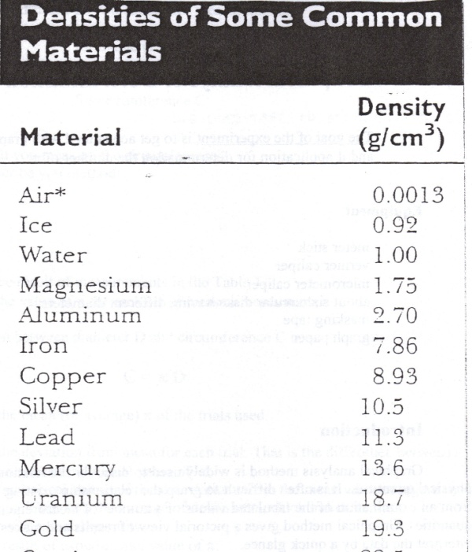

1. Calculate a percent error between the calculated object density and the tabulated value of density for the chosen material, and record.

**Conclusion:**

**Sources of errors:**